**Install e-Dokyumento ISO**

1. Burn the ISO into CD and use it to boot from PC; or boot directly the VM using the ISO.
2. Select ‘Boot system installer’ and press enter.

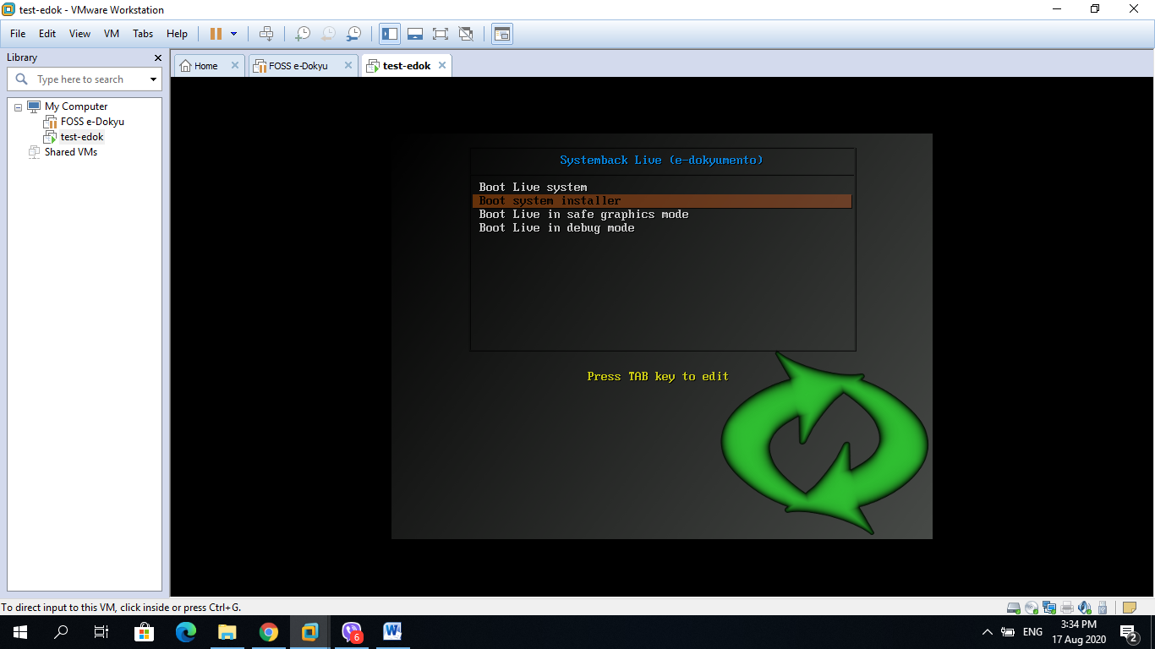

1. The system will boot until the desktop login appears.

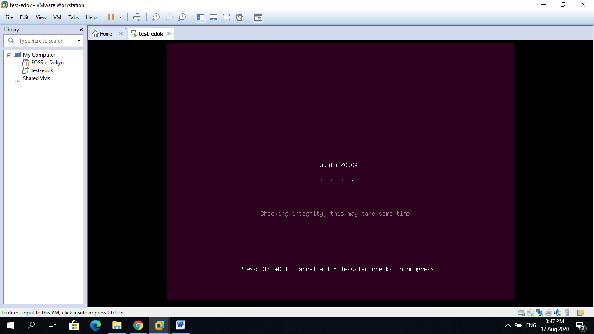

1. On the desktop login, type ‘root’ for username press enter, then type ‘admin@123’ for password.

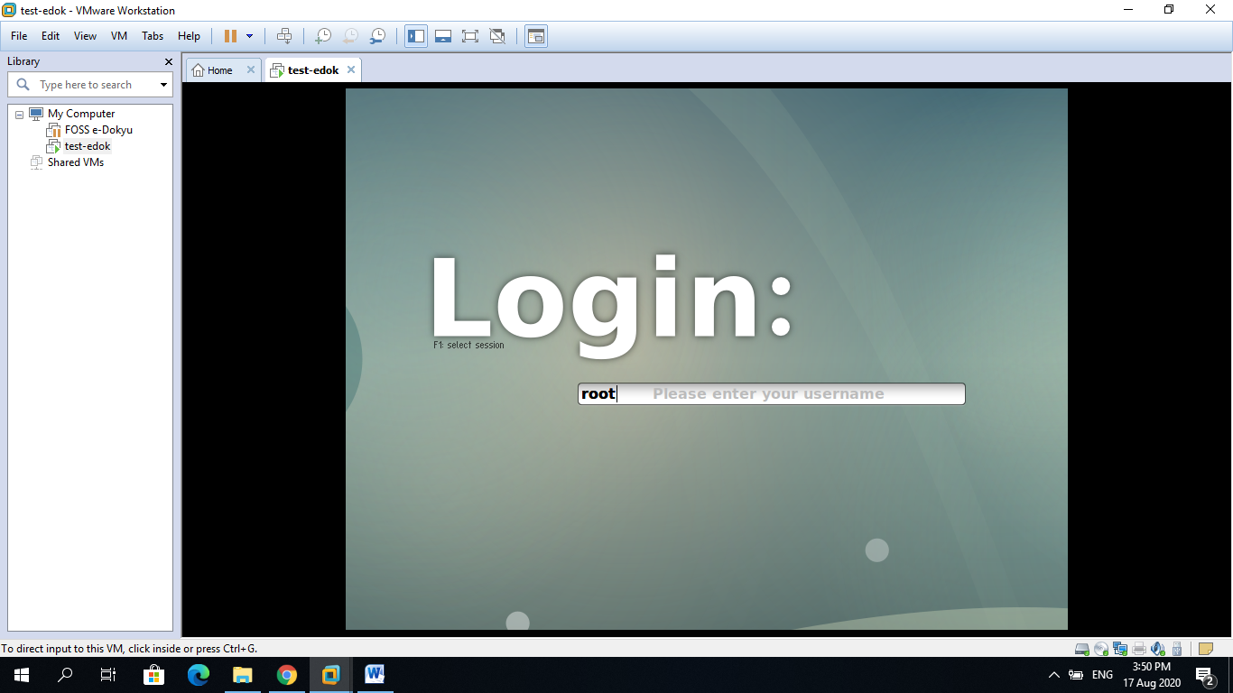

1. Upon showing the System Install window, type-in the needed information in the textbox then click next.

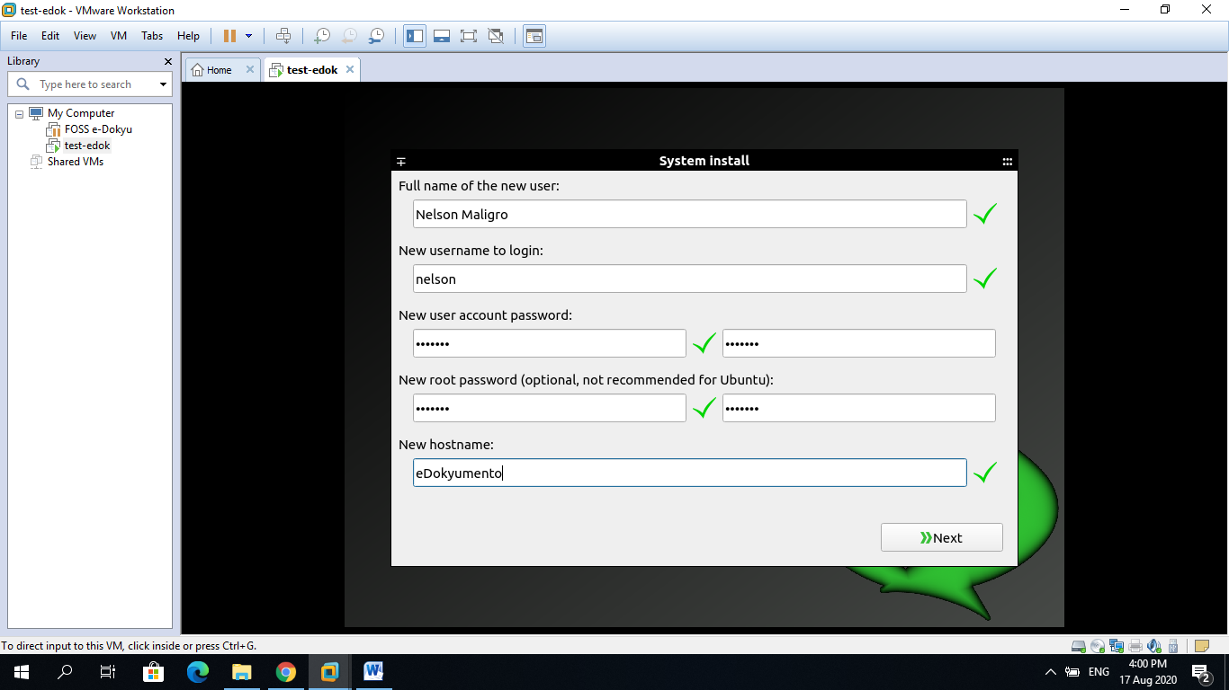

1. Select the partition and click ‘delete’ button.

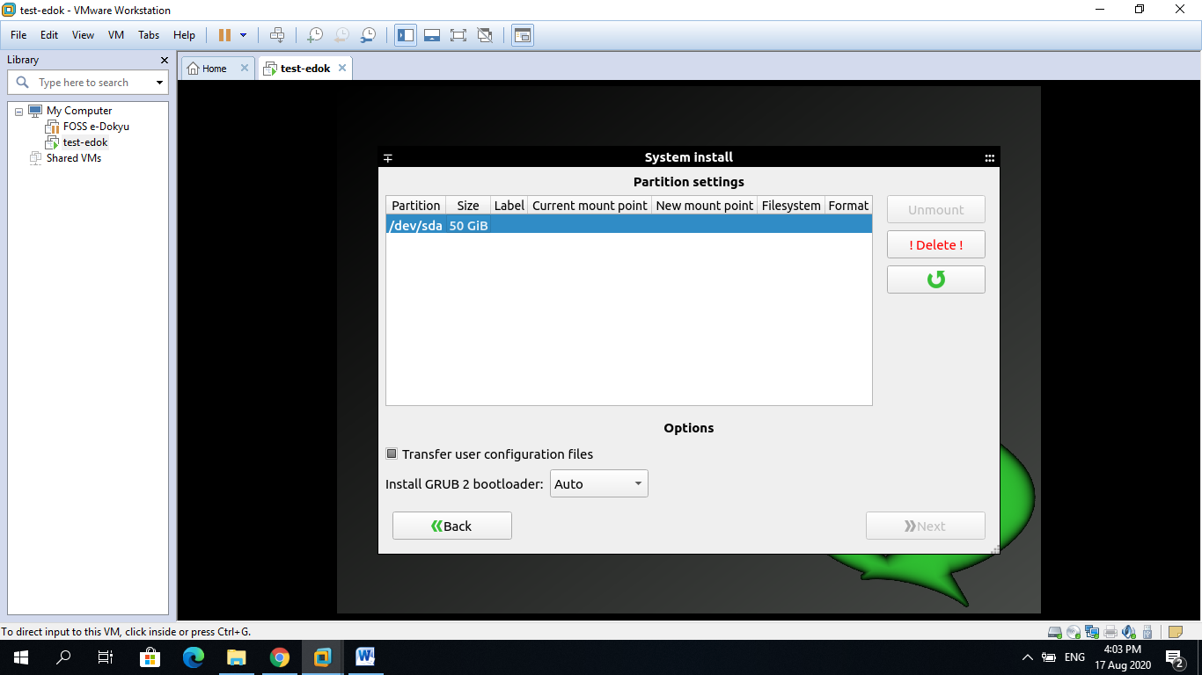

1. Allocate disk size for the ‘Swap’ drive and click apply button.

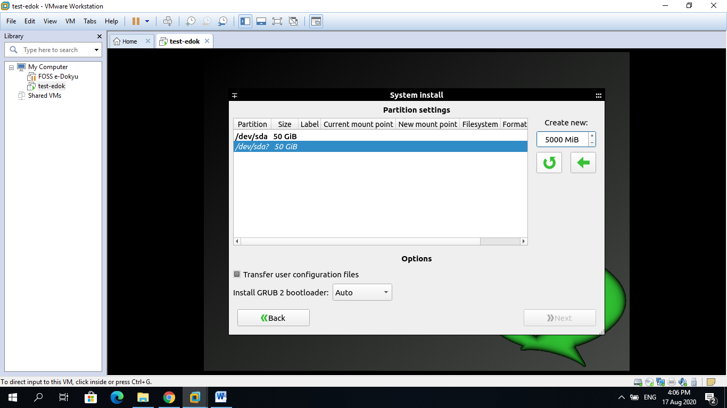

1. Allocate the remaining size for the root drive and then click apply.
2. Select the created Swap partition and select SWAP in the mount point. Then click apply button to effect the changes.

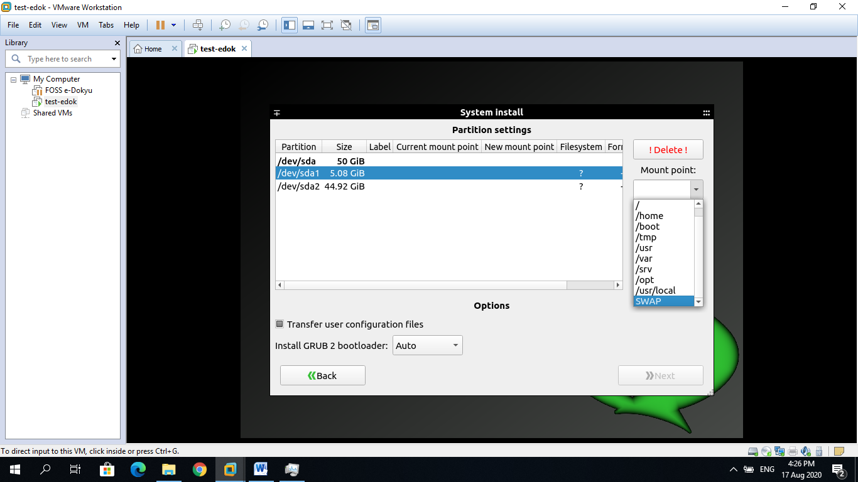

1. Select the created root drive and select ‘/’ in the mount point. Then click apply button to effect the changes.

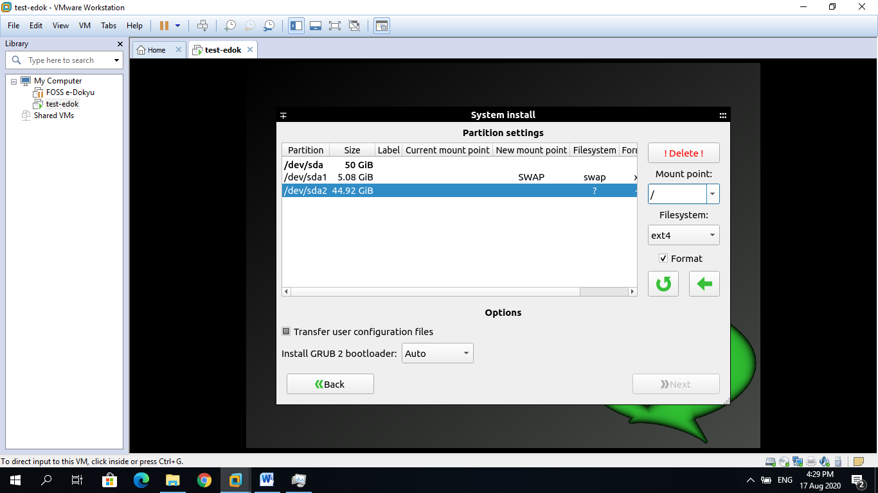

Click this to apply

1. Click ‘Next’ button then click ‘start’ button to start the installation.

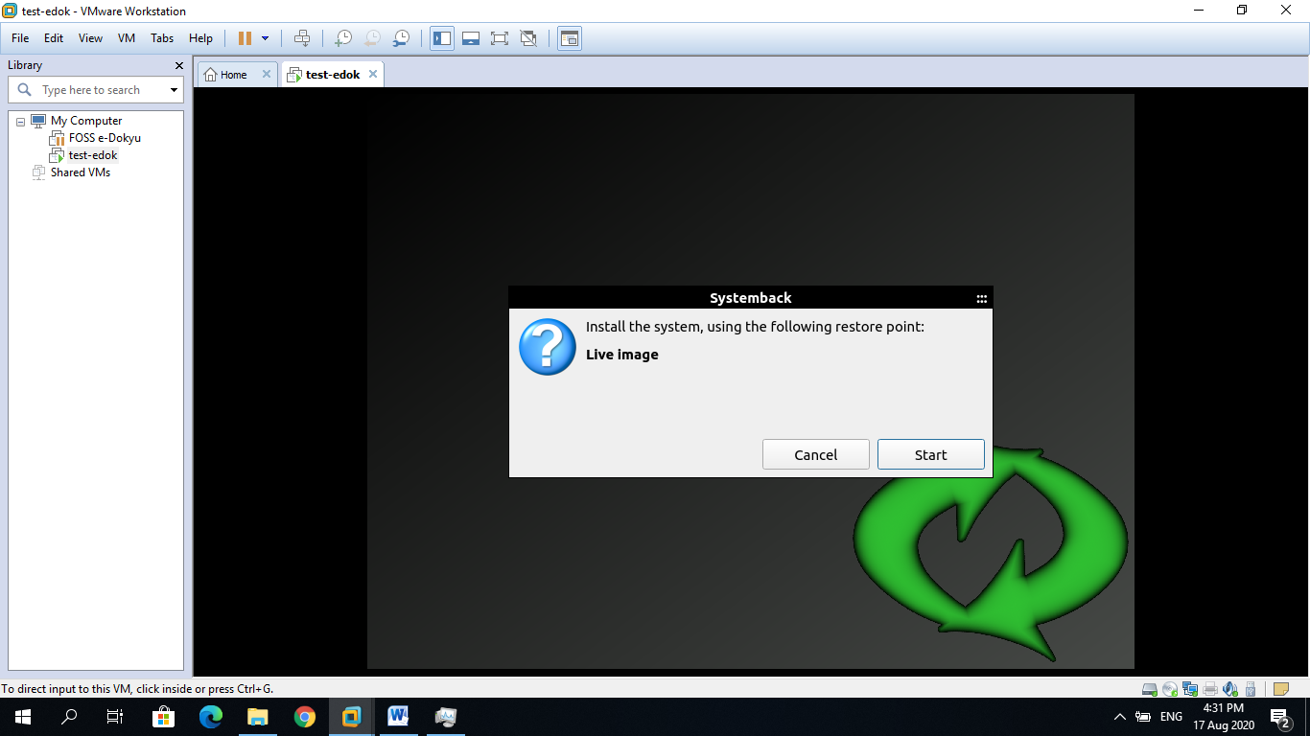

1. Installation will take several minutes.

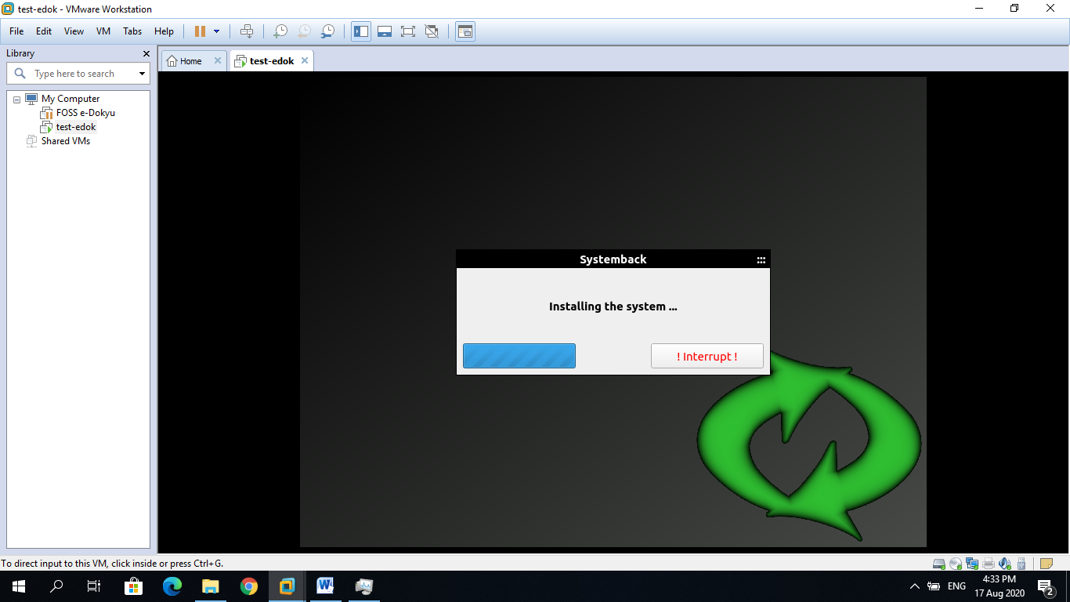

1. When installation is done, reboot the machine.
2. On desktop login, switch to Linux CLI console by simultaneously pressing “ctrl + alt + f1” or “ctrl + alt + f3”.
3. Login with ‘root’ and ‘admin@123’ or the encoded password during installation.
4. Move the default ‘drive’ folder of e-dokyumento from ‘/opt/’ to the root drive. Do this by invoking the command ‘mv /opt/drive / ’.

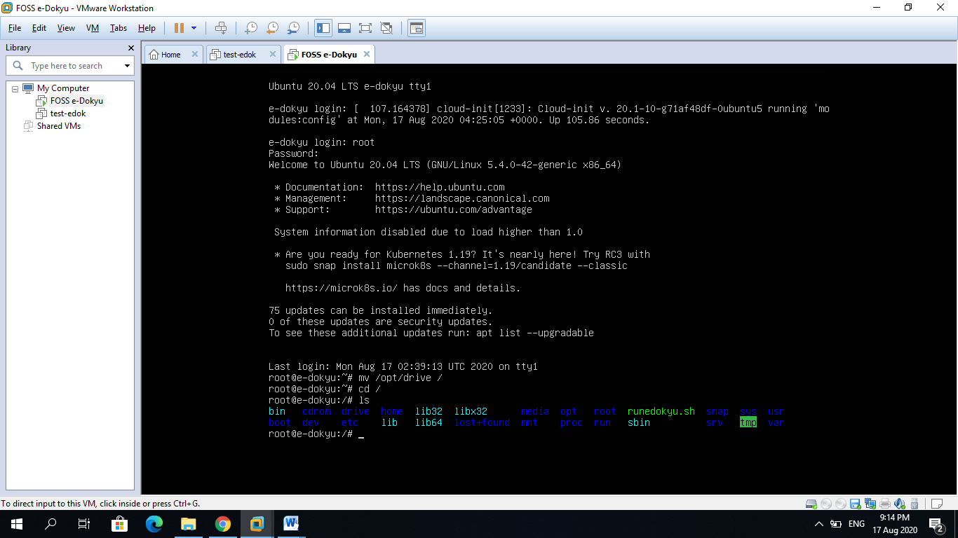

Move to root drive

1. **You are done!.....**To access the web application, get the IP address of the machine by invoking the command ‘ifconfig’ then use the resulting IP address when typing the URL in the browser.

Note: Configure the User Accounts:

* 1. Login as Administrator and admin@123 for the password
  2. Go to “View/Edit/Del” User Account
  3. Edit all accounts to match the following access privileges
     + 1. EXECUTIVE – refers to executive level managers in an organization
       2. MANAGER – refers to 1st level managers or immediate supervisor in a department/branch/group
       3. STAFF – refers to the staff or subordinate personnel of the manager/supervisor
       4. SECRETARY – refers to the staff who receives and release documents for the organization. Commonly referred to receiving section.
       5. SysAdmin - refers to the system administrator for the e-dokyu